**GMIEC user manual**

**v0.01**

Table of Contents

List of figures 3

How to install GMIEC 4

How to run GMIEC 4

GMIEC graphic interface 5

GMIEC-AN: type of analysis 5

GMIEC-AN: Input data 6

GMIEC-AN: Upload of the data 7

Upload of file with the association between the genes and drugs 8

Upload of annotation file and bed file 8

GMIEC-AN: parameters for the analysis 8

How to run GMIEC-AN 9

Analysis with a gene-list 9

Analysis with a bed file 10

Analysis with all genes 11

Analysis with few omics datasets 12

How to run GMIEC-VIS 13

How to run GMIEC-res 14

Parsing output GMIEC-AN 14

Visualization of the modules 15

# **List of figures**

Figure 1 GMIEC interface. 5

Figure 2 Windows with the options to run GMIEC 5

Figure 3 Window to upload the omics data (gene-expression, copy-number, methylation, mutation, clinical) 7

Figure 4 The window to specify other options to run GMIEC-AN, and in the case that the user upload only two dataset-sets must specific the kind of experiment uploaded using the available list (e.g. gene-expression, copy-number). 7

Figure 5 The window to upload the bed file and a list of genes and the option to run GMIEC-AN. 8

Figure 6 Users can upload the annotation files through the ‘GMIEC- Input annotation window. 8

Figure 7 Pipeline of analysis in the case that the user provides a custom gene list. 9

Figure 8 Pipeline of analysis in the case that the user provides a bed file. 10

Figure 9 Pipeline of analysis with the option to consider all genes in the data-sets 11

Figure 10 Procedure to run GMIEC with few data-sets. 12

Figure 11 Interface of GMIEC-VIS 13

Figure 12 Window to parse the GMIEC-AN output 15

# **How to install GMIEC**

From an R-shell copy and paste the R code available in the INSTALL.R file.

install.packages(c("shiny",

"shinydashboard",

"klaR",

"formattable",

"bcp",

"plyr",

"kableExtra",

"randomForest",

"heatmaply"),depencies=T)

if (!requireNamespace("BiocManager", quietly = TRUE))

install.packages("BiocManager")

BiocManager::install("ChIPpeakAnno")

BiocManager::install("ComplexHeatmap")

The experts users can run script as follow:

source(‘INSTALL.R’)

# **How to run GMIEC**

From an R-shell copy and paste the following R-code:

library(shiny)

library(ComplexHeatmap)

setwd("/directory/GMIEC_shiny2-master")

options(shiny.fullstacktrace=TRUE)

shinyAppDir(appDir="/directory/GMIEC_shiny2-master")

# **GMIEC graphic interface**

After that the user install and run GMIEC, appear the graphic interface of the application (Figure 1). This consists of a brief description with the functionalities of GMIEC. A menu of the left of the window contains the links to the application available on GMIEC. In details, to run one analysis click on ‘GMIEC-AN’. Otherwise, if the user wants to explore the results of GMIEC can click on ‘GMIEC-vis’ or ‘GMIEC-results’.

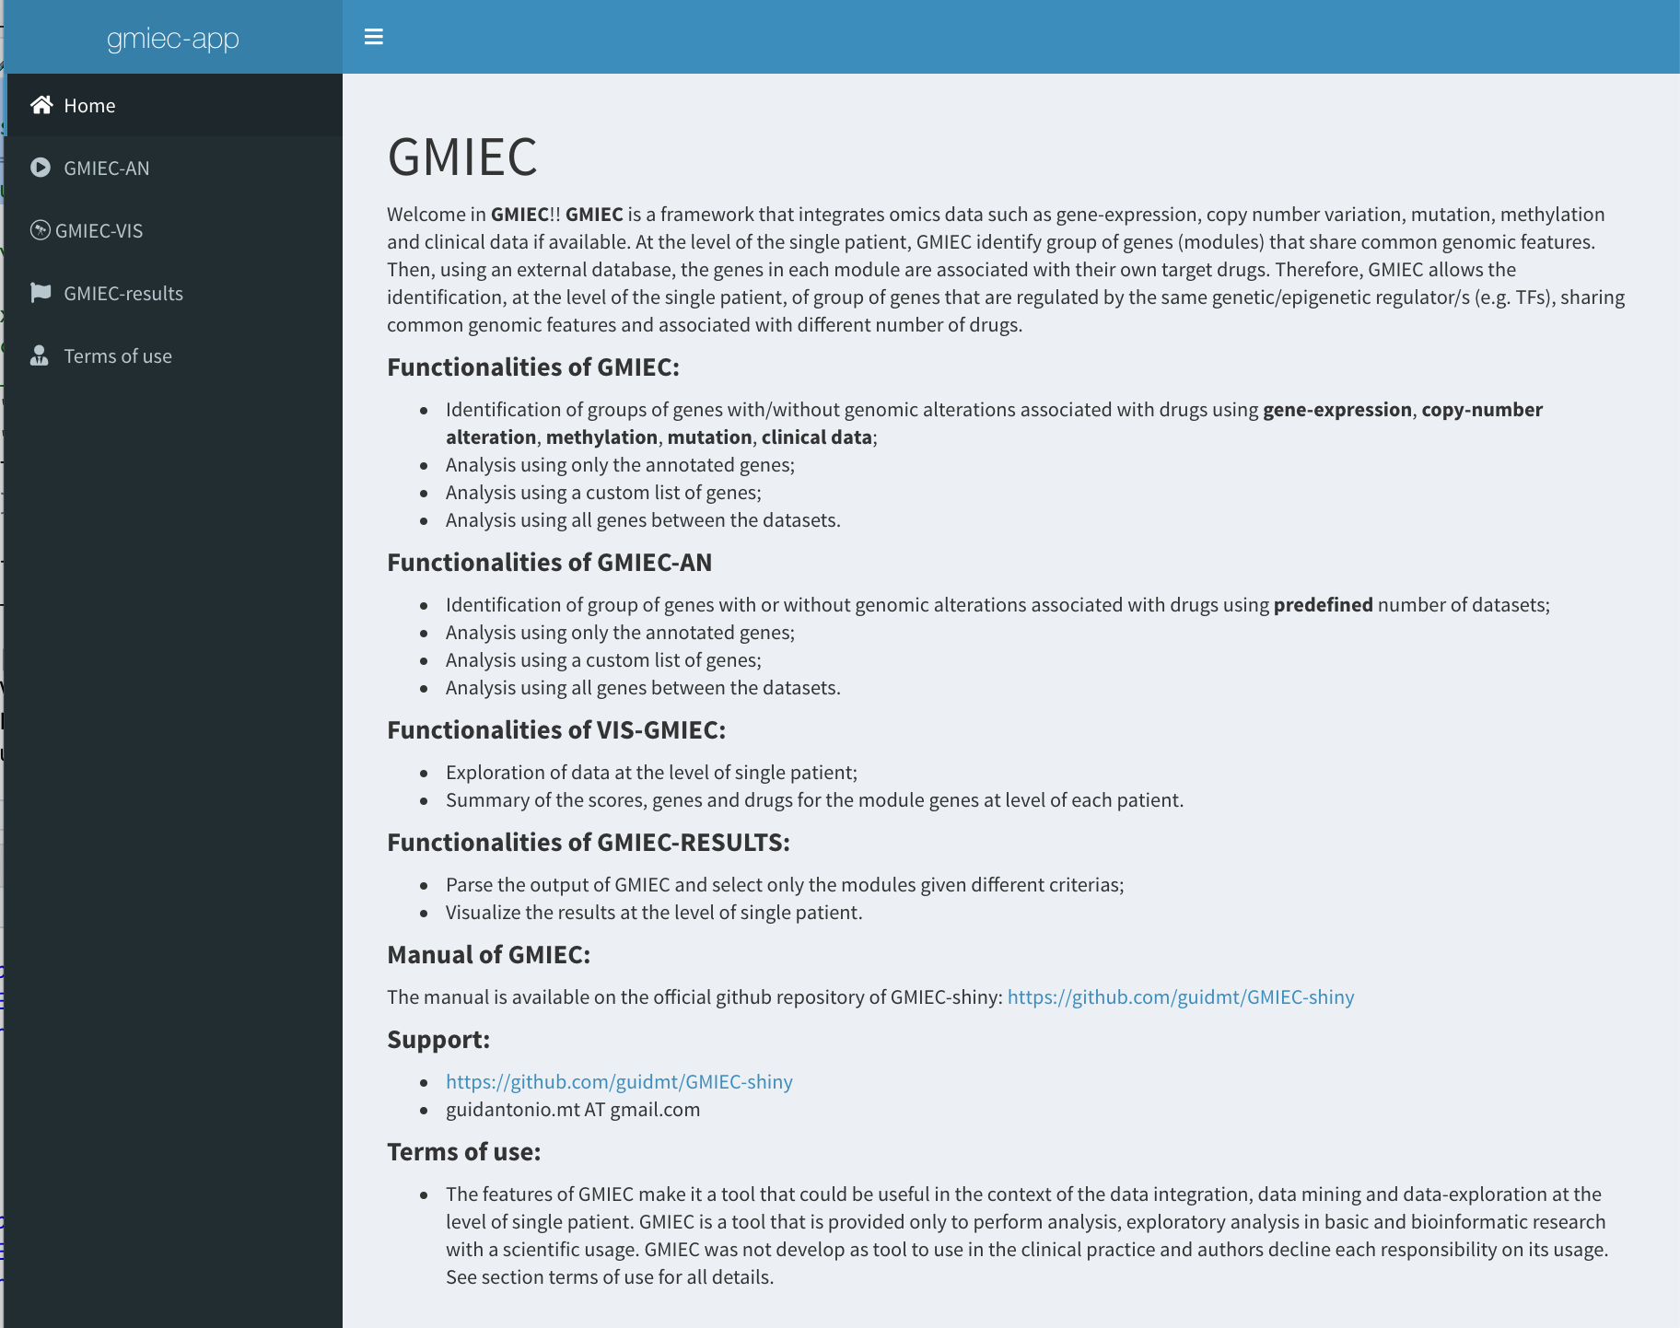

Figure 1 GMIEC interface.

# **GMIEC-AN: type of analysis**

GMIEC-AN it is the main functionalities to run one analysis with GMIEC. Several options are available to run one analysis with different input files (Figure 2). If the user wants to analyse provide as input a bed file, in that case must click on ‘Use only the genes annotated’. Otherwise if the user provide a lists of genes or wants to all genes available in the omics data (e.g. gene-expression or methylation data) can click on ‘Use all genes’ or ‘Use a list of genes’.

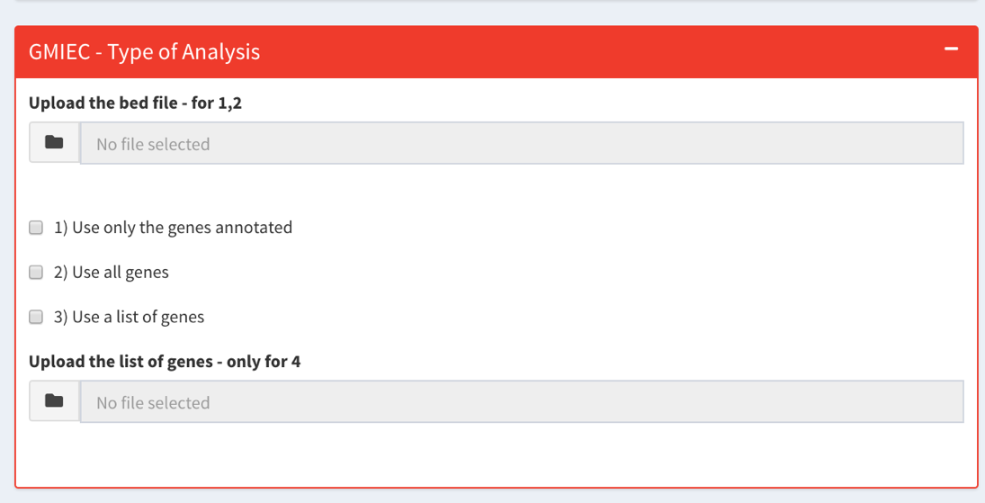

Figure 2 Windows with the options to run GMIEC

# **GMIEC-AN: Input data**

The input files required by GMIEC are:

1. omics data: gene-expression, copy-number, epigenetics and mutations data in the form of tab-delimited files. In the case the genetic variants data, the user might create a file with only the mutations of interest (e.g. with deleterious variants).
2. drugs-genes table: a tab delimited file with the association between genes and drugs. The user can create a custom file selecting only the drugs and genes that are important for the disease of interest or download them from our repository.
3. clinical data: a tab delimited file with clinical variables to include in the analysis.
4. list of genes: a list of genes of interest (e.g. genes of a pathway). The list of genes can be directly uploaded by the user. Otherwise if the user provides a file with genomic coordinates, the list of genes is obtained through an annotation step.

The principal output of GMIEC are table delimited files that can be easily open with Microsoft Excel or Libre/Open Office. This output contains the gene modules (gene groups or GMs) and drug modules (drug groups or DMs) identified during the analysis. The output reports also columns containing the scores, that are a quantification of the level of genomic alterations of the genes in GM, and the fraction of drugs linked to specific GMs. GMIEC allows also to generate a dynamic report (see Figure S1) that can be interrogated directly through a GUI interface, GMIEC-VIS. GMIEC-VIS allows to visualize for each patient, tables with statistics related to the gene’s modules, and the lists of drugs and genes identified. GMIEC-results is another sub-application that allows to parse the output of GMIEC and automatically select a module for patient. GMIEC-results can be also used to visualize the levels the omics data for the genes inside each module.

# **GMIEC-AN: Upload of the data**

To run one analysis with GMIEC-AN it is possible to upload a minimum number of omics datasets (Figure 3). To upload the data use the window GMIEC- Input dataset. Note: it is mandatory the uploading of a table with the clinical information of the subjects.

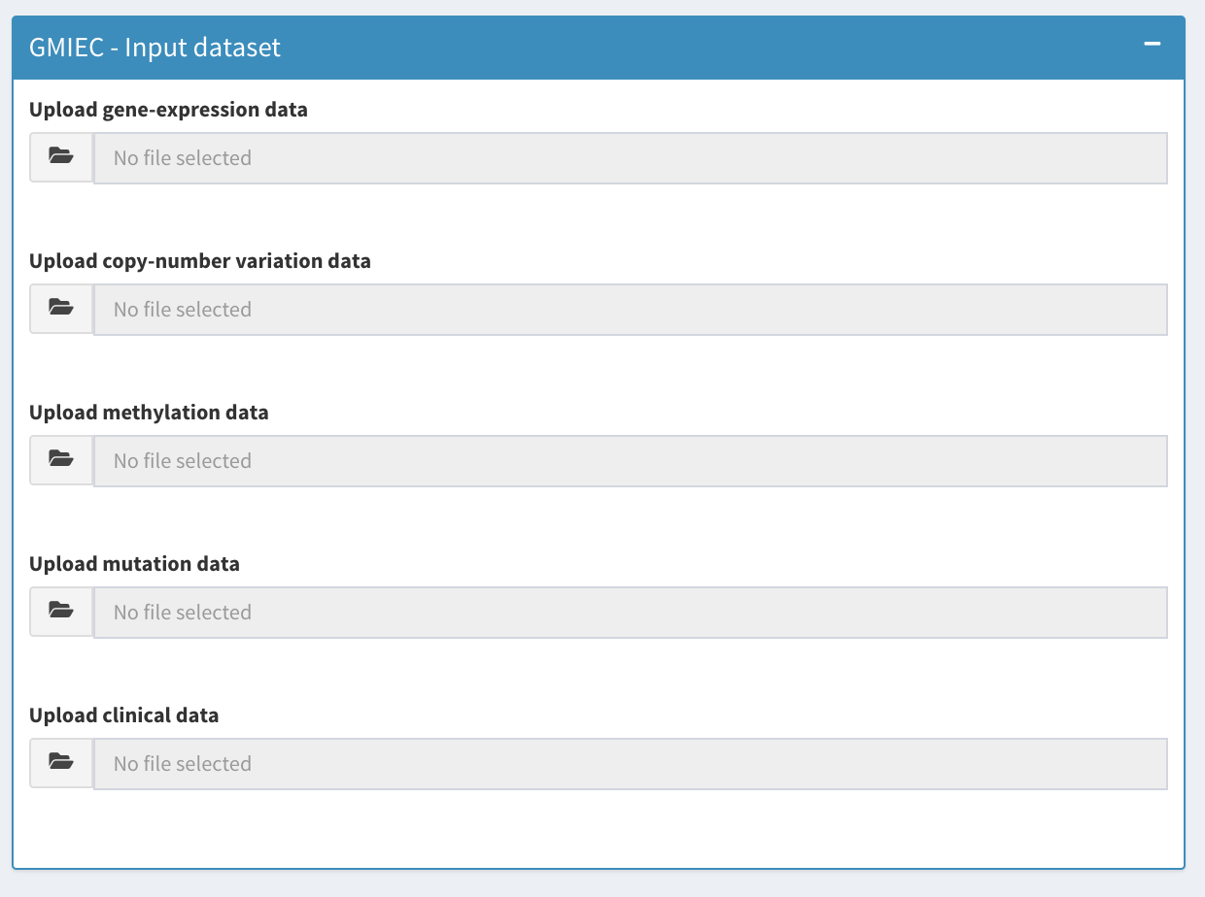

Figure 3 Window to upload the omics data (gene-expression, copy-number, methylation, mutation, clinical)

In the case that the user upload only two datasets (e.g. gene-expression or copy number data) must specific in the window ‘GMIEC - Parameters Analysis’ the source of the experiments uploaded files (e.g. gene-expression or copy-number) and click on ‘Analysis only two datasets’, Figure 4.

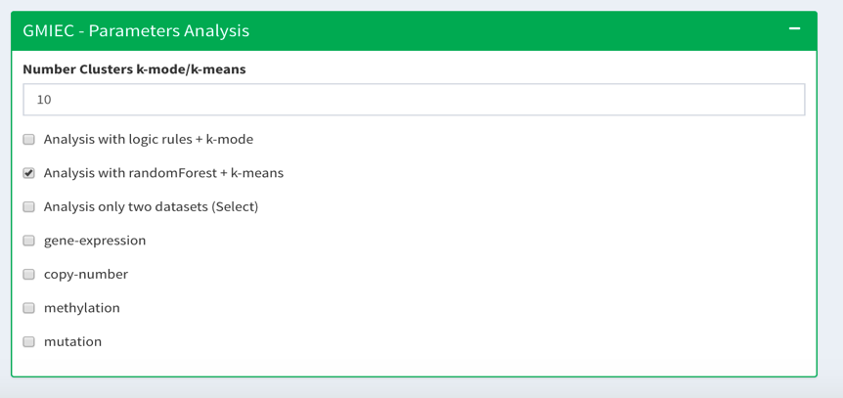

Figure 4 The window to specify other options to run GMIEC-AN, and in the case that the user upload only two dataset-sets must specific the kind of experiment uploaded using the available list (e.g. gene-expression, copy-number).

## Upload of file with the association between the genes and drugs

A file with the association between each gene and drugs it is mandatory. To upload this file use the specific window ‘GMIEC-input drugs’.

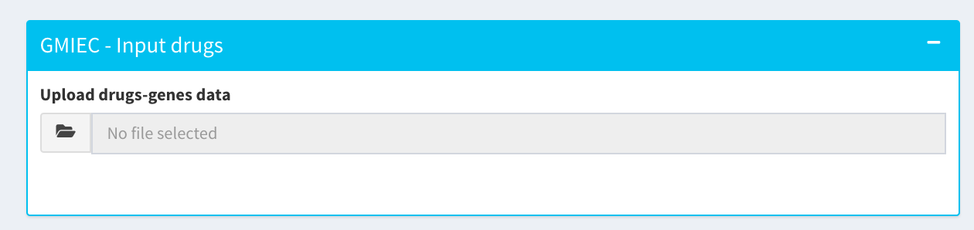

## Upload of annotation file and bed file

The user can upload a bed file. This file it is annotated by GMIEC to get the genes to consider during the analysis. The user can provide to GMIEC the bed file using the window ‘GMIEC – Type of Analysis’. At the same time it is mandatory upload an annotation file (e.g. from RefSeq), and specify the parameters of annotation using the window ‘GMIEC – Input annotation’.



Figure 5 The window to upload the bed file and a list of genes and the option to run GMIEC-AN.

Figure 6 Users can upload the annotation files through the ‘GMIEC- Input annotation window.

# **GMIEC-AN: parameters for the analysis**

To specific the kind of method to analyse the data click on ‘Analysis with logic rules + kmeans’ or analysis with randomForest + k-means, see Figure 4.

# **How to run GMIEC-AN**

## Analysis with a gene-list

1. Upload the omics data (e.g. gene-expression, copy-number, methylation, mutation, clinical). The file with the clinical information it is mandatory.
2. Upload a table delimited file with the association between the genes and drugs, this file it is mandatory.
3. Click on ‘Use a list of genes’, upload the list of genes.
4. Change the parameters of analysis.
5. Click on run analysis, wait the end of analysis.
6. Click on download.



Figure 7 Pipeline of analysis in the case that the user provides a custom gene list.

## Analysis with a bed file

1. Upload the omics data (e.g. gene-expression, copy-number, methylation, mutation, clinical). The file with the clinical information it is mandatory.
2. Upload a table delimited file with the association between the genes and drugs, this file it is mandatory.
3. Upload an annotation file using the window ‘GMIEC – Input annotation’, specify the distance of annotation.
4. Use the ‘Type of analysis’ interface to upload the bed file. Specify ‘Use only the genes annotated’
5. Click on run analysis, wait the end of analysis.
6. Click on download.



Figure 8 Pipeline of analysis in the case that the user provides a bed file.

## Analysis with all genes

1. Upload the omics data (e.g. gene-expression, copy-number, methylation, mutation, clinical). The file with the clinical information it is mandatory.
2. Upload a table delimited file with the association between the genes and drugs, this file it is mandatory.
3. Click on ‘Use all genes
4. Change the parameters of analysis.
5. Click on run analysis, wait the end of analysis.
6. Click on download.



Figure 9 Pipeline of analysis with the option to consider all genes in the data-sets

## Analysis with few omics datasets

The user can upload a minimum of two omics data-sets (e.g. gene-expression, copy-number).

Indipendently by the type the analysis (use a list of genes, use only the annotated genes, all genes), the user can run an analysis with GMIEC-AN using the follow procedures:

1. Upload the gene-expression, copy-number, clinical data
2. Click on ‘Analysis only two datasets’
3. Specify the type of datasets uploaded (e.g. gene-expression, copy-number)
4. Use the procedures described in the previously pages to run the analysis



Figure 10 Procedure to run GMIEC with few data-sets.

# How to run GMIEC-VIS

GMIEC-Visualization (GMIEC-VIS) is another interface that allows to upload the results of GMIEC-AN and explore the data. This application consists of two sub sections. The first one ‘*Summary Heatmaps GMIEC’* allows the visualization of heatmaps containing the values of drugs, genes, sad or *S-score* values computed by GMIEC-AN (Supplementary Figure 4). These heatmaps are interactives, the user can zoom in or out to explore the results. The second section of GMIEC-VIS allows to inspect the results of GMIEC at the level of single patient. The user can select a given patient to visualize a table that contains several statistics for each module (e.g. number of genes, number of drugs, scores drugs, scores genes, sad or *S-score*). GMIEC-VIS generates also tables with the drugs and genes identified in the module with external links to NCBI and DGIdb.

Procedure to run GMIEC-VIS:

1. Upload the output of GMIEC-AN using the window ‘Upload results GMIEC’
2. Click on ‘Create report!’. Wait for the results.

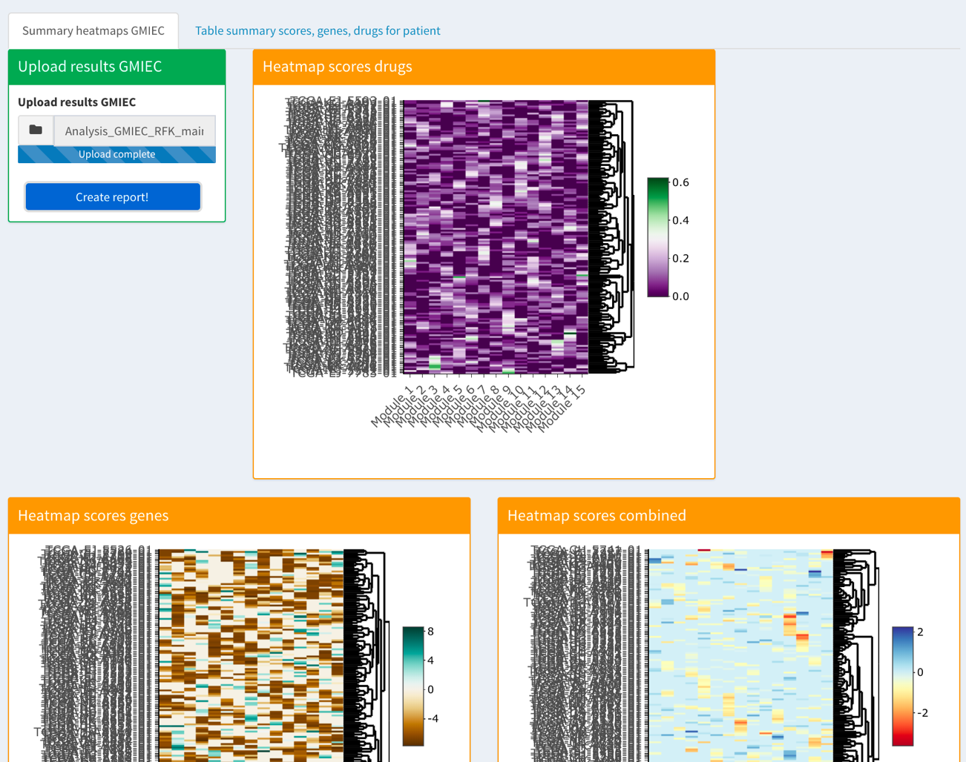

Figure 11 Interface of GMIEC-VIS

# How to run GMIEC-res

## Parsing output GMIEC-AN

The output obtained from GMIEC-AN can be uploaded on GMIEC-results. This application allows i) the automatic selection of the modules from each patients ii) the parsing of GMIEC-AN output in a simple form iii) visualize the results of GMIEC-AN. The concept underlying GMIEC-results it is select group the genes in one patient that are the most over activated (e.g. genes with high copy-number) or over suppressed (e.g. genes hypermethylated) and that are targets of drugs (See Supplementary Material and Methods for details). Although this approach is a simplification, GMIEC-results it is a straightforward approach to support the users with few computational skills to parse the output of GMIEC-AN and easily identify the modules that could be biologically more relevant. More expert users can use the original output file created by GMIEC-AN to select the modules using custom approaches. The output of GMIEC-results is a tab delimited file with the rows that correspond to the patients and four columns with the patient id, the score of the modules, the genes and the drugs inside each module. GMIEC-results implements four strategy that prioritizes the modules of each patient based on the maximum or the minimum values of *S-score* and SAD score:

* Module active: in this case GMIEC-results select from each patient only the module with the highest score *S-score.*  This method can be useful to detect the most active groups of genes in one patient.
* Module inactive: GMIEC-results in this modality select from each patient only the module with the lowest score *S-score*. This approach can be useful to detect the most inactive groups of genes in one patient.
* Module active with drugs: GMIEC-results select from each patient only the module with the maximum SAD score. This method can be useful to detect the most inactive groups of genes in one patient.
* Module inactive with drugs: GMIEC-results select from each patient only the module with the lowest SAD score This method can be useful to detect the groups of inactive genes associated with drugs.

Procedure to run GMIEC-res and parse the output of GMIEC-AN:

1. Upload the output of GMIEC-AN
2. Select the method used for the analysis
3. Choose the type of output to create.
4. Click on Create Report, wait for the end of analysis and click on ‘Download’

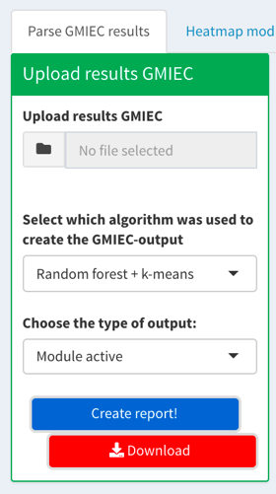

Figure 12 Window to parse the GMIEC-AN output

## Visualization of the modules

1. Click on the tab ‘Heatmap module patient’
2. Upload the results of ‘Parse GMIEC results’ in the field ‘Upload results GMIEC’
3. Upload the gene-expression copy-number, methylation, mutation, and genes-drugs files.
4. Click on ‘Create report’, wait the end of analysis.
5. Select the ID of the patient to visualize the module of the current patient.



Figure 13 Procedure to run GMIEC-res and visualize the modules.